**Course:** High Performance Computing Lab

**Practical No. 7**

PRN: 22510057

Name: Ashutosh Gundu Birje

Batch: B8

**Problem Statement 1:**

Implement Matrix-Vector Multiplication using MPI. Use different number of processes and analyze the performance.

**Program**

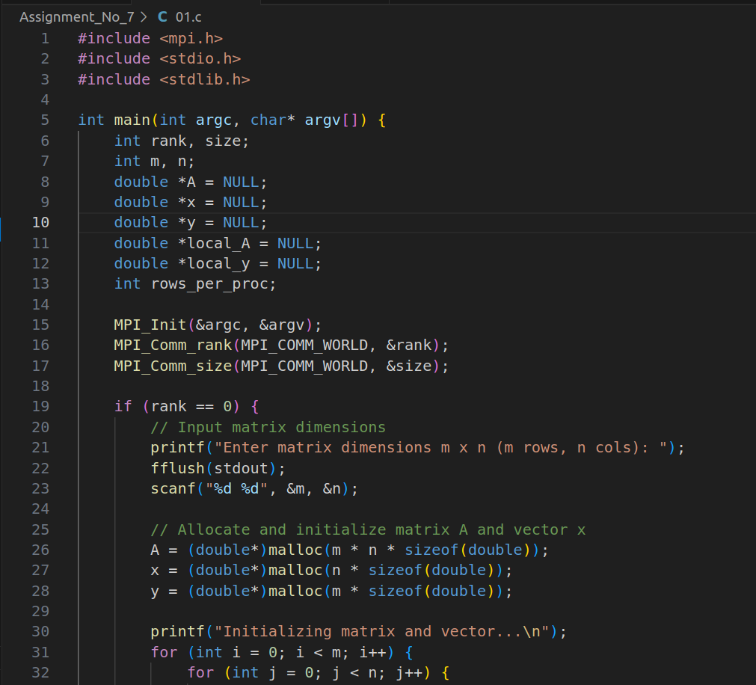

**Screenshot:**

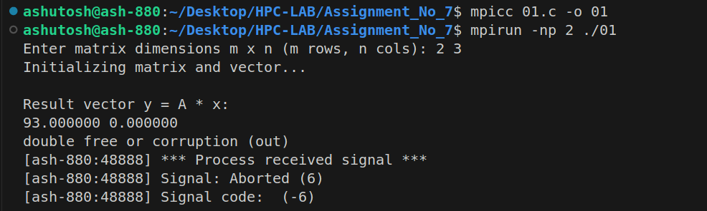

**Problem Statement 2:**

Implement Matrix-Matrix Multiplication using MPI. Use different number of processes and analyze the performance.

**Program:**

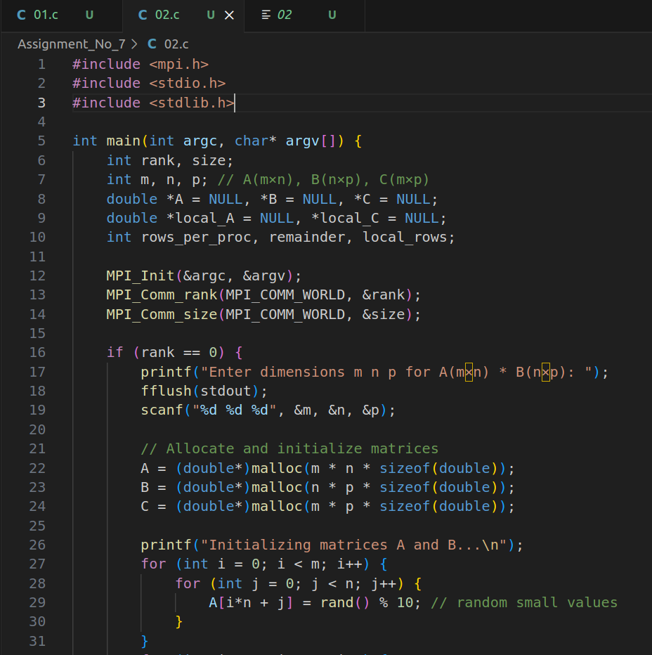

**Screenshot:**

